**Highlights: ADA initiatives and involvement and participation in HLPF**

The meeting of the high-level political forum on sustainable development in 2017 convened under the auspices of the Economic and Social Council, was held from Monday, 10 July, to Wednesday, 19 July 2017; including the three-day ministerial meeting of the forum from Monday, 17 July, to Wednesday, 19 July 2017.

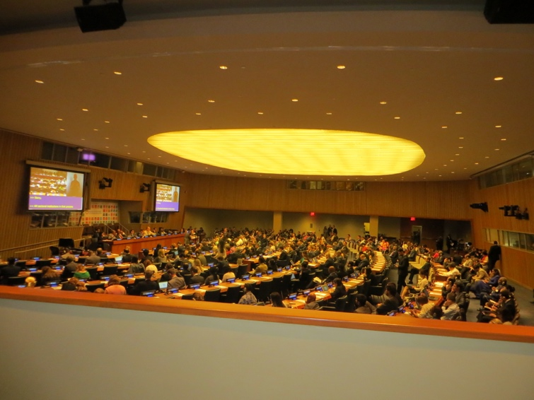The theme was "Eradicating poverty and promoting prosperity in a changing world". The set of goals to be reviewed in depth were the following, including Goal 17. Strengthen the means of implementation and revitalize the Global Partnership for Sustainable Development, that will be considered each year:

* Goal 1. End poverty in all its forms everywhere
* Goal 2. End hunger, achieve food security and improved nutrition and promote sustainable agriculture
* Goal 3. Ensure healthy lives and promote well-being for all at all ages
* Goal 5. Achieve gender equality and empower all women and girls
* Goal 9. Build resilient infrastructure, promote inclusive and sustainable industrialization and foster innovation
* Goal 14. Conserve and sustainably use the oceans, seas and marine resources for sustainable development

Many ADA members from Nepal, Pakistan, Malaysia, India, Japan, S. Korea, Thailand participated in HLPF, from 10 to 19th July, at New York.

Apart from organizing a side event with TAP network on 14th July ([“***Beyond VNRs: Global Workshop on Civil Society Reporting for SDG16”***](http://tapnetwork2030.org/wp-content/uploads/2015/04/SDG16ParallelReportingWorkshop_Programme.pdf)***)*** , ADA also participated in Weekend meetings organised by A4SD and TAP meeting on ‘Justice and SDG16: National Civil Society Advocacy Workshop’. Followings are the highlights of the HLPF where ADA was engaged actively:

Opening & Session 1- Where are we in year two of implementation of the 2030 Agenda? Monday, 10 July 2017, 9:00-10:30, Conference Room 4

Mr. Frederick Musiiwa Makamure Shava, Permanent Representative of Zimbabwe to the United Nations, President of Economic and Social Council, made the opening remarks. He deliberated the issues of eradicating poverty and and promoting prosperity in the changing word. He also presented the overview of first week program.

First week is dedicated to review of this years selected SDGs which would also highlight the challenges of middle income countries. Where we stand globally on each of the SDGs.

Based on the trends and available data, their limitations and recommendations will be proposed through the lenses of countries.

He also concurred that Regional dimension is very important: 2 sessions are dedicated

1. Regional implementation of 200 gender and SDGs.
2. 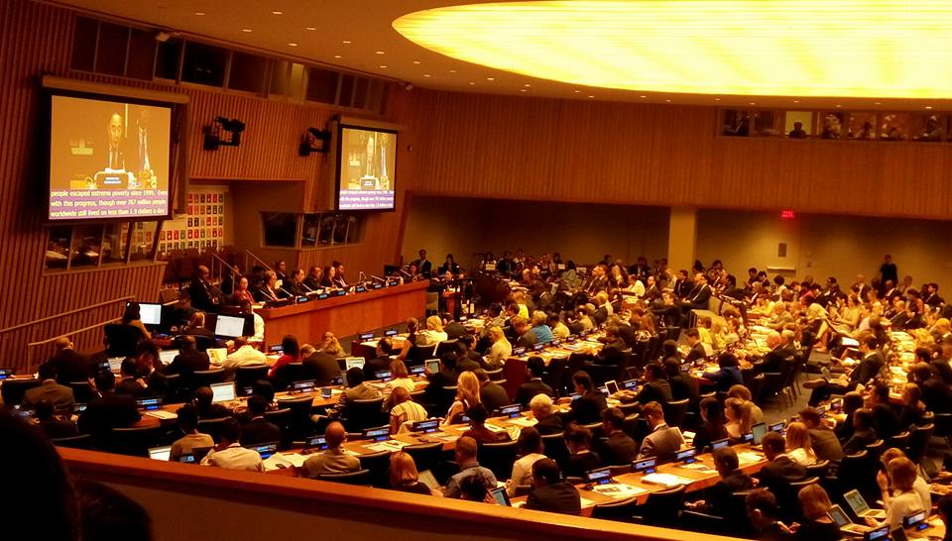Other session- regional dimension of the ministerial declaration.

He also talked on 44 VNR reporting countries which shows strong political will, and availing opportunities to exchange views.

This was followed by Introduction of Secretary-General’s SDG Progress Report by Mr. Wu Hongbo, Under-Secretary-General of Economic and Social Affairs, United Nations

Mr. Wu Hongbo talked about eradicating fundamental deprivation, living sustainably within the natural boundaries of the earth, by working together, where every human being realize his/her full potentials

He also announced to provide the special thematic review of goals 1,2,3,5,9 and 14 in addition to goal 17- based on global indicators frameworks.

He emphasized need to start working across silos, strengthening science policy interface and promoting the generation and dissemination of innovations of information.

Later there were statements from keynote speakers.

Session 2 Implementation at the regional and sub-regional levels

During the session two, Ms. Shamshad Akhtar, executive secretary of ESCAP talked about the availability and quality of data which impacts the report. She deliberated on Goal 5 and declining women’s share in labor market, loss job opportunities for women. She further highlighted the issue of increasing Inequality in Asia – Pacific region, where large segment denied basic services. She also drew the attention on Asia pacific region being most disaster prone areas in the world and loss of fossil fuel through out the region.

Later, Ms. Olga Algayerova, Executive Secretary of ECE discussed that progress is often mixed. Gender equality is a good indicator, however much remains to be done, for example gender pay gaps are higher!! She also highlighted the need of private sector finance and redistribution of property and wealth to reduce inequality in the region apart from domestic resource mobilization , domestic governance, public expenditure governance to name a few.

Later there were discussions around the issue of Lesson learnt in the means of implementation Asia pacific forum of sustainable development (APFSD) has taken the SD agenda. The goals and MoI are captures well in APFSD platform.

Session 3 Thematic review Eradicating poverty and promoting prosperity in a changing world: Addressing multi-dimensions of poverty and inequalities

This session addressed the theme through the lens of its multi-dimensional nature. A panel of experts with diverse backgrounds facilitated discussions aiming at deepening understanding and appreciation of the various dimensions and their inter-connections, in the process of which practical recommendations will be made towards the end of HLPF.

Review of implementation: SDG 1

The overriding objective of poverty

The session deliberated the issues of poverty across the globe. In most of the developing countries the basic minimal survival is 16 USD its for a day. It was also discussed that relative poverty occurs more in the developing countries and that’s how poorest of the world are left behind and they need to be mainstreamed.

The session also examined the interlinkages and implication for policy-making and implementation to realize goal 1 bearing in mind in particular that to eradicate poverty, its causes and manifestations must be fully understood and addressed. Poverty eradication can only be achieved when interconnected factors are addressed together. Such factors include inclusive growth, livelihoods and decent work, social protection, access to basic infrastructure and services, food security, nutrition, health, education, empowerment of women and girls, environmental sustainability, governance and more equitable access to opportunities and distribution of income and wealth. Poverty eradication demands cross-cutting, coherent initiatives that make people less vulnerable, reduce the risks of setbacks, break patterns of discrimination, and enable all women and men to fully participate and benefit from economic growth. Concerted effort is needed to tackle the most prevalent and reoccurring constraints to eradicating poverty.

There were stories of change from china and Africa. It was discussed that poverty in Africa can only be reduced if people reduce their dependencies and become independent. Modern farming can also boost economy. Improve productivity in agriculture can lead to poverty reduction. Apart from that, investment, capacity building and micro data and lots of international norm setting is important to reduce poverty and inequality. Social dialog in all form is a key to reduce poverty by all means.

Gender inequality, female youth unemployment rate is almost double than the man, and it impacts women more than man. Decent working condition is being demanded by the women groups to reduce inequality.

**ESCAP Side Event on Regional Road map**: The Regional Roadmap represents the aspiration of the region towards achieving the SDGs and the 2030 Agenda. There is no doubt that there is substantial space and need for regional cooperation on attaining the SDGs, and in particular for facilitating the MOI. There is no denying this will be of immense benefit to the developing and least developed countries in the region. It is clear that unless major progress made on the MOI, most countries will find it difficult to achieve the SDGs.

The Asia-Pacific region is responsible for half of the resources and is the home to 2/3rd of worlds population, 767 million poor in world and out of approximately 330 million in Asia –Pacific – 260 million is accounted by south Asia region.

It was highlighted that cooperation with shared vision can strengthen sustainable development. A transformative and holistic Regional Roadmap relies on addressing structural impediments and systemic barriers.

It must take into serious consideration targeted and sustained commitments on development finance and co-operation as well as inclusive collection and disaggregation of data to track the gaps and progress condition of the marginalized sectors.

It must provide institutionalized space, and support for widest possible stakeholders participation at all levels and ensure principle of non-regression in civil society participation, including people with disability. This is important for attaining broader ownership of the development agenda.

**Side Event - The Global Invisible Mosaic 10th Floor Conference Room The Church Centre for the United Nations 777 United Nations Plaza, New York Community Mapping the SDGs for Subnational Implementation**

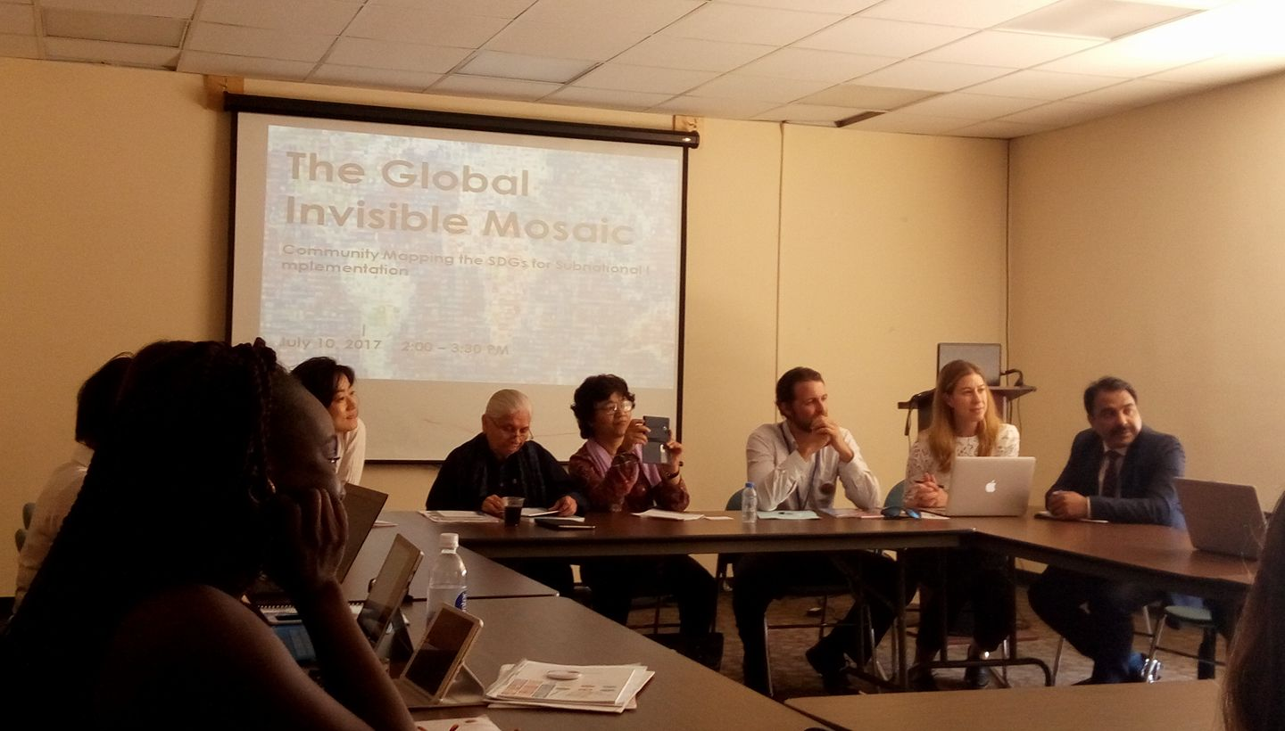Most discussions surrounding the SDGs have focused on the setting of goals and indicators. Less attention has been paid to discussing the roles and responsibilities that different stakeholders should take in achieving these goals at all levels. Given the scope and ambition of the SDGs, it is clear that governments a l o n e c a n n o t a c h i e v e t h e agenda. They must also facilitate participation of all sectors of society, particularly civil society organisations (CSOs), inclusive of all major groups of sustainable development (i.e., youth and children, women, farmers), who are uniquely positioned to draw upon local knowledge to tailor the ambitious global-development agenda to specific local contexts. This invisible mosaic of organizations demonstrating real progress on the 17 SDGs - estimated to be in the tens of thousands worldwide - can provide valuable insight into the strategies and lessons learned when translating the global agenda to local action.

CSO representatives from Canada, India, Nepal, S Korea and Pakistan talked about the SDG implementation in their countries and role of civil society in outreach, information dissemination and capacity building on SDGs.

The CSos also spoke about the challenges and barriers that they face in the community while capacitating them on the grass root level issues related to SDGs. Missing data is the biggest challenge in effective mechanism apart from accountability and resources

**Side event Of the sugarcoated VNRs and National Realities;** why its important that VNRs must be build on National Reviews 11th July 2017, 1530 hours to 1700 hours Even Hotel, 221 East 44th Street, Midtown East, New York, Organizers: Beyond Copenhagen, CECOEDECON and PAIRVI

Objectives

* Whether VNRs follow the 9 principles laid down in the Para 74 of the agenda 2030, VCRG of the SG
* National and sub national consultations are supposed to be the foundation for the VNRs, whether these have been held in the real spirit
* Status of CSOs participation, generally and in the VNR process
* What do VNRs don’t tell, policy incoherence, implementation challenges, lack of coordination among ministries, national and state governments
* Three concrete suggestions to make VNRs more inclusive, appropriate, robust.

Side event: Civil Society Report on SDGs : Agenda 2030' of INDIA, 2017 on 12th July 2017 at Baha'i International Community Center, 866 UN Plaza, New York from 10:00 AM to 11:30 AM.

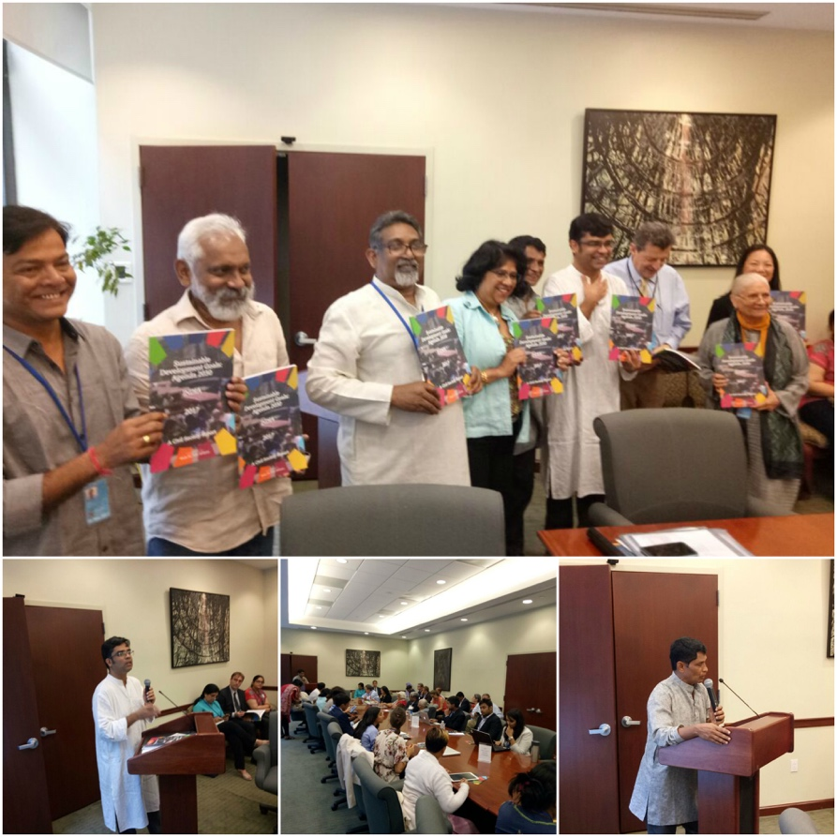***Civil Society Report on SDGs: Agenda 2030***, a Civil Society initiative anchored by **Wada Na Todo Abhiyan (WNTA)** was re-released on 12th July, 2017, at Bahai International Community Center, New York among the presence of more than 100 CSO’s from all over the globe. The report highlights ‘Demanding right for equal citizenship’.

The government of India earlier promised to have the voices of the CSOs in the official VNR process, however, there has been no interaction while writing the VNR and later there is no mention of the contribution of the CSOs in the official VNR report in India.

The CSO has demanded monitoring and accountability report , which needs to be followed by the government of India. The report is extremely important to see if the goals and targets of SDG have met in the last three years.

Critique: The report doesn’t deal with goal 17 of the SDGs. The report also lacks **discussions on** financial and the trade system, climate change discussion, etc.

4-fold accountability framework was suggested by Amitabh Behar,

* Popularizing the SDG’s-need to incorporate the most marginalized community, to make it accessible t everyone
* We need to start working far more closely with the government , to see what policy observers recommend
* Developing accountability mechanism by the CSOs (CSOs will certainly come back with goal 17)
* Use monitoring to use social accountability tools in terms of holding the government accountability

**Side Event:** [“***Beyond VNRs: Global Workshop on Civil Society Reporting for SDG16”***](http://tapnetwork2030.org/wp-content/uploads/2015/04/SDG16ParallelReportingWorkshop_Programme.pdf) around the 2017 HLPF 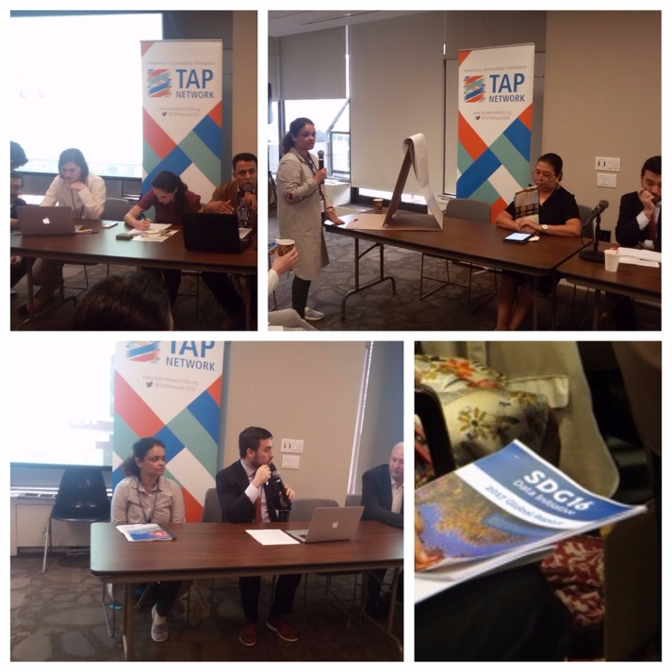 organized by the Transparency, Accountability & Participation (TAP) Network, Asia Development Alliance (ADA), Article 19 and Transparency International, Friday, 14 July 2017; 9:30 AM – 2:00 PM.

The workshop had the following objectives:

1. To provide a platform for sharing of best practices around current SDG civil society parallel reporting efforts in different contexts
2. To further discussions around methodologies, approach, guidelines and templates for SDG civil society parallel reporting, and to review the TAP Network Paper on SDG16 “Parallel Reporting”
3. To help identify knowledge and capacity gaps and needs within civil society on SDG parallel reporting, with an aim to explore further work and partnerships to address these needs

CSO representatives from various Nepal, Sri Lanka, Bangladesh, Brazil, Chile presented their reports on SDG 16.

**Discussions and outputs**

22 percent dalit and indigenous women are trafficked in Nepal.

gaps: paradigm between laws and priority

challenge between women and dalit women

lack of access to information

lack of awareness and empowerment is a big gap

economic empowerment is another challenge

no specific specific government policy

linking with international arena another challenge

segregated quality and quantity of data

**GCAP-APSD and other’s- a side event on: SDG 1 and Inequality,** Wednesday, 12 July 2017, 15:00 to 16:30 pm at Baha'i International Community UN Office.

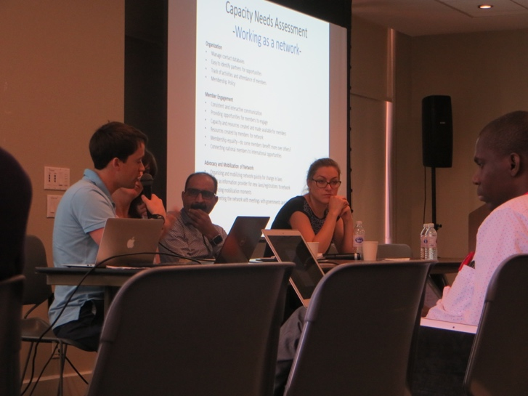The event focused the following points:

* How will reducing inequality relate with the achievement of SDG 1?
* People’s Perspectives on Inequalities and Poverty

The main points of discussions were:

Extreme poverty leads to extreme inequality

Many countries in the world are experiencing high Gini Co-efficient

Levels of inequality, which by definition is not compatible.

The biggest challenge in the inequality it impacts civil and political rights.

Access to resources, and empowerment, and where people going to enjoy their civil and political rights.

There is a need to gradually develop a more sustained focus on inequality

The structural causes of poverty are:

1. Social exclusion – reference to CSO report of India-poverty from the dimension of caste (dalit word doesn’t appear in govt.)
2. Political economy-neo-liberal framework-marginalizing more
3. Natural resource is getting starved, significant amount of privatization happening land, water. Further marginalization of poverty.

Eradicating poverty:

* Finding structure in inequality is quite difficult. (Brazil case)
* The transferring money is not sufficient to reduce inequality.
* employment creation
* workers right
* social dialog has a key role to play and, social protection to ensure that no one is left behind
* there is a need to reverse the current role
* international level standards are the foundation of social justice
* it needs political will to be implemented
* tax and injustice
* the aspect of gender in the inequality
* labor should be rewarded with the same remunerations irrespective of gender
* recognize informal workers, secure effective access to social protection to the unpaid, groups.

**Side Event- Speaking Truth to Power: citizen accountability and inclusion in the HLPF Voluntary National Review process, July 15th and 16th at the United Nations Church Centre organized by A4SD and IFP**

* Women and children are left behind.
* Meaningful participation of women and the youth.
* Women face gender discrimination, people living under extreme poverty, people living with HIV AIDS, street families,
* Economic and huge political crisis in many countries
* Civil Society need to take specific ownership
* Sort and search countries by region in the database
* mission of A4SD is the grass root involvement
* shrinking spaces for the civil society around the issues of SDG 16
* Ensuring global democracy with building up regional coalition

**Important information from the HLPF:**

*Development and Access to Information (DA2I)* is the first of a series of annual reports that will monitor the progress countries are making towards fulfilling their commitment to promote meaningful access to information as part of the United Nations Sustainable Development Goals. Please go to the [link](https://da2i.ifla.org/) to get the full information

**Civil society response to the Ministerial Declaration of the High Level Political Forum**

#### Civil Society Statement at the High Level Political Forum - Response to the Ministerial Declaration – A4SD

The 2017 High Level Political Forum on Sustainable Development 10-19 July 2017 counted with the participation of almost 2,500 representatives from civil society around the world, an increase of 1,000 from 2016. This is a clear sign of the engagement and commitment to the Sustainable Development Goals on the part of civil society. Action for Sustainable Development includes over 1,700 members in over 150 countries who share a clear enthusiasm and determination to make a strong contribution to this agenda and to share our expertise with decision-makers. However we are concerned that the spaces for dialogue remain too limited.   
  
**1) Responding to the 2017 theme: "Eradicating poverty and promoting prosperity in a changing world"**  
  
The theme of this year’s HLPF recognises the central need for poverty eradication as a vital step to guarantee a sustainable future for all. We note the reference to ‘transformative efforts’ and the need to reach those furthest behind first.  
  
Although we welcome the stated aim of UN member states to end poverty and combat inequalities, we remain concerned that what has been presented in Voluntary National Reviews this year demonstrates that the pace of change is still too slow, and the reality remains that the scale of inequality globally is rising. Information provided by civil society groups, through their [Civil Society Reports](http://civicus.us6.list-manage.com/track/click?u=9283ff78aa53cccd2800739dc&id=535b4eed30&e=4fee33f2ec) also indicates that wealth concentration is continuing at a ferocious pace, while economic weakness is met with even greater ‘austerity’ by governments.  
  
These are universal challenges. Governments in North and South continue to reduce investment in public services, accelerating the process of dismantling social protection and labor legislation, with long-term underfunding of essential health, education, gender, innovation and environmental programs. Simultaneously there are increasing investments in the private sector and reductions in corporate taxation. If these worrying trends remain unaddressed, they will undermine the universal commitment to eradicate poverty, and will instead contribute to its exacerbation.  
  
**2) The central role of peaceful, just and inclusive societies**  
  
Action for Sustainable Development notes the reference to the importance of peaceful, just and inclusive societies in the Ministerial Declaration, in particular the need for good governance and the effective rule of law. It is our view that shared principles of freedom of assembly and association, coupled with freedom of expression provide the underlying bedrock for healthy inclusive societies. Member States must recognise that we will not realize the targets in Agenda 2030 if communities continue to be excluded from decision-making processes.  
  
In this context the degree of openness of civic space in the countries under review at the HLPF 2017 is also concerning. In 2017, of 44 countries under review, only 10 are considered ‘open’, while a further 12 are perceived as ‘narrowed’, including Italy, Slovenia, Japan, Chile and India. What is most concerning is that the other half of countries under review are evaluated to be ‘obstructed’ including Brazil and Kenya; ‘repressed’ including Zimbabwe and Bangladesh; or ‘closed’, including Belarus and Azerbaijan ([see HLPF index](http://civicus.us6.list-manage.com/track/click?u=9283ff78aa53cccd2800739dc&id=b59b31bc90&e=4fee33f2ec)).  
  
It is particularly concerning to witness the rise of national populist tendencies in traditional democracies, such as the US, and UK, where leaders are perceived to be inflaming an already difficult situation for minorities, through the use of language which contributes to their exclusion. While at the same time many newer democracies are also backsliding on key indicators of good governance. This analysis suggests that the commitment to open inclusive societies is not felt on the ground in a wide range of countries and that there is an urgent need for governments to work in partnership with other stakeholders to ensure that this commitment, which they agreed, is delivered in practice.  
  
**3) National level implementation of the Voluntary National Reviews (VNRs)**  
  
Now, in the second year of implementation of Agenda 2030, it is critically important to ensure that the HLPF VNR process provides a real mechanism for accountability of the delivery by member state of their commitments, including meaningful engagement with citizens. The HLPF has the potential to be a much needed moment for reflection, review, in order to  identify good practice and jointly address challenges.  
  
In order to understand how far the review process has engaged citizens and civil society, we have carried out national reports in 20 of the 44 VNR countries on the participation of civil society in the reviews , there are several notable trends:

* At least 10 countries have established high level governmental committees or parliamentary groups to lead the delivery of Agenda 2030
* In a few cases there is still a lack of specific implementation plans
* In many cases although there is a sense that the SDGs are included in existing national plans, the ‘transformational’ aspect of the agenda has been significantly diluted or lost
* Reporting on the inter-connected dimension of the agenda and its synergies across different thematic areas is limited due to budget constraints- each government department has a limited remit. Intersectionality, climate change and the pledge to leave no one behind, are the areas that have the most potential for transformational change but are inadequately represented in the reports.
* The local level of government is still not very aware or engaged with Agenda 2030
* Engagement with civil society and broader stakeholders remains patchy

We also would like to stress that the implementation of the SDGs should be part of an integrated approach with the Paris Climate Agreement. One of the tools which could promote an integrated implementation approach is precisely national reporting. We urge member states to do their best to include climate change in their planning, delivery and consequently in the formulation of their Voluntary National Reviews.   
  
It is vital that governments consider different climate scenarios and how these might impact on the delivery of the SDGs. Reflecting the agreement to implement the goals as a whole package, member states need to identify how climate change intersects with the pledge to Leave No One Behind, for example by identifying which groups are most vulnerable to climate impacts and how this relates to issues of marginalisation and discrimination.  
  
**4) Role of the United Nations**  
  
We note that the UN is providing an increasing amount of information and documentation on the UN DESA HLPF website, which provides a useful entry point for engagement. **However we are very concerned that there is still no space to feature the national Civil Society Reports on the UN website**.  
   
It is essential for UN country level teams to engage more directly in ensuring specific national plans are delivered which provide support to citizens, particularly those who have been left behind. It is clear that more work should be done by the UNDP and other delivery agencies to contribute towards ensuring that SDG implementation is delivered in an inclusive way and that they are able to work with civil society and key stakeholders at a national level to drive a truly transformational agenda.  
   
We would welcome a full response on the UN’s position and its expectation relating to citizen and civil society participation in the implementation and reporting.  
  
**5) Role and capacities of civil society**  
  
Our country reports, demonstrate that civil society is mobilising. There are a number of active national coalitions of civil society around the world, such as in Kenya, Brazil, India, Nepal, including in so-called ‘developed’ countries such as Italy, Sweden and Japan, which have been very active in working together to ensure all voices are heard at the national level and to enable a broad inclusive process of dialogue.  
  
However, the opportunities for engagement for CSOs are still limited, even though Agenda 2030 foresees meaningful participation of civil society. We therefore urge Member States and the United Nations to take the following recommendations into account:

* To ensure the success of Agenda 2030, civil society’s role in monitoring and implementation of the agenda must be more than just an informal one.
* CSOs must be given access to formal roles, guaranteeing their participation in
  1. clear consultation processes on government implementation plans and measures
  2. formal representation mechanisms which oversee implementation efforts
  3. channels for participation in accountability processes, amongst others
* The international community should support and fully resource a coordinated approach to the capacity development of civil society to enable implementation and effective monitoring of the Agenda across the globe.

Finally, we reaffirm our call for the development and adequate resourcing of structured and meaningful engagement of CSOs, in Agenda 2030 implementation and monitoring at all levels.  
  
**About Action for Sustainable Development**

Action for Sustainable Development is a civil society platform with over 1,700 members in over 150 countries, we work collaboratively to create space and facilitate citizens and civil society organisations at local, national, regional and global levels to organise, mobilise, advocate and act collectively in pursuit of sustainable development.  
  
We came together to inspire and to commit to actions that empower all peoples, especially those who have been marginalised, and in order to collectively tackle the root causes of inequalities, injustice, human rights violations, poverty, environmental degradation and climate change. We seek to be part of creating a world where social, environmental and development justice is assured and all people are able to live in a prosperous, healthy, secure and peaceful environment.